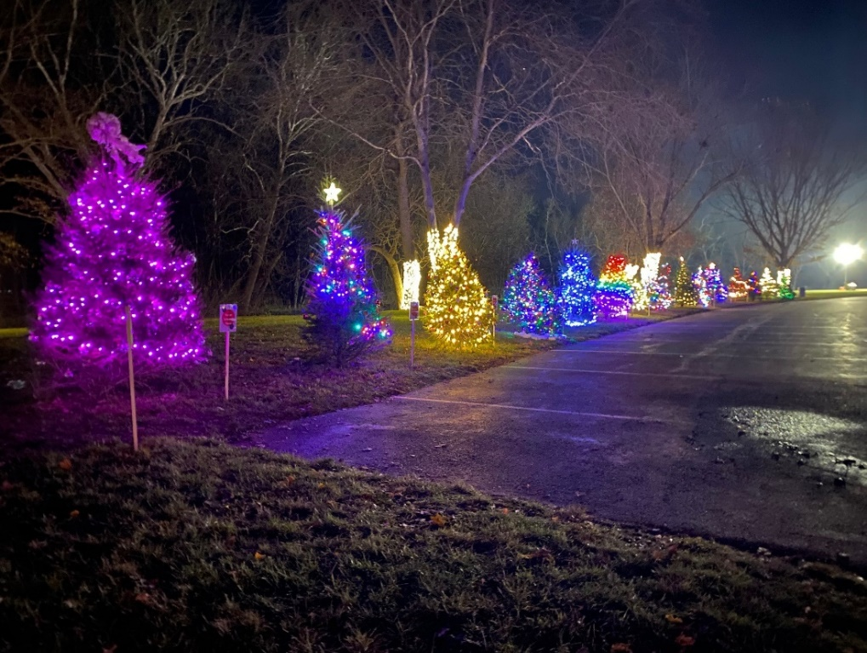

**Adopt -a- Tree**

Holiday Fundraiser Program

**Help us brighten up the holiday season while supporting your Community Programming!**

Each year, Families, Businesses, and Organizations **Adopt-a-Tree to decorate** and display at Covered Bridge Park throughout the month of December. This culminates in the Adopt-a-Trees being ceremoniously lite with the rest of the park during our Annual Tree & Bridge Lighting Event Saturday, December 7, 2024! Adopting a Tree is a great way to kick off the Holiday Season with your family, team, or co-workers. See details below!

**GUIDELINES FOR TREE ADOPTEES:**

* The minimum donation to Adopt-a-Tree is $55.00. All proceeds support future community events and programs offered by SWT Parks and Recreation. You are then encouraged to decorate your tree in any way you please, following a few guidelines:
* Tree Adoptees are responsible for decorating their tree and for providing all ornaments/ribbons/balls/etc.
  + We highly recommend adhering all decorations to the tree with pipe cleaners or ties that can be twisted tightly to the branches.
* Your tree is limited to 500 LED lights (white or colored). LED ONLY!
* No glass/breakable decorations. No tinsel please!
* You must provide a 20 ft. (minimum) OUTDOOR/ALL WEATHER extension cord to extend from your tree lights to our Industrial Cord. No indoor cords will be permitted!

**Remember,** the trees will be out in the elements, and therefore subjected to winds, rain, snow, etc. While South Whitehall Township employees and volunteers will be monitoring the park decorations and trees, we ask that you keep a keen eye on your tree and make sure that nothing is damaged. The trees will be staked into the ground and up the trunk of the tree however, if strong winds occur, some trees may lean or fall. The Township will do their best to rectify the situation. If you notice something out of the ordinary with your tree/decoration/stand, please contact the Parks & Recreation Department at 610-398-0401 ext. 211 or by email at [matulal@southwhitehall.com](mailto:matulal@southwhitehall.com).

**PLEASE SEE THE NEXT PAGE FOR TIMELINE, DECORATING, and REMOVAL DETAILS.**

**TIMELINE FOR TREE DECORATING AND REMOVAL:**

* Tree Delivery- Trees will be delivered and set in staked stands throughout Covered Bridge Park the last week in November.
* Decorating- Tree Adoptees will have from the last Friday in November to the first Friday in December to decorate.
  + When you arrive to decorate, look for your Family/Business/Groups name tag on your tree.
  + Please leave the name tag on your tree so everyone knows which one is yours!
* Test Lighting- On Saturday, December 7, 2024 at 12:00 p.m. the Township will hold a test lighting at the park. If malfunctions occur with your tree, you will be notified immediately. If you need assistance, we will help any way we can so your tree is beautiful and ready for the Tree and Bridge Lighting event that evening.
* Removal of Decorations & Trees- All tree decorations MUST be removed during the first week of January. Any decorations that are not collected will be discarded by the Township.
* We will contact Adoptees with any important information and reminders. Thank you!

**Please PRINT what you would like written and displayed on your tree tag** (ex. In Memory of John Doe, The Beckett Family, John Doe Incorporated, Scout Troop 8), and submit this completed form along with your Donation (minimum $55.00).

**Checks can be made payable to** “**South Whitehall Township**, and mailed to

South Whitehall Township Parks & Recreation, Attn: Tree Lighting

4444 Walbert Avenue

Allentown, PA 18104.

___________________________________________________________________________________ Tree Tag Information (Family Name, Business Name, Etc.)

___________________________________________________________________________________ Contact Person for the Adoption

_____________________________________ ________________________________________ Telephone Number Email Address

_____________________________________________________________________________________ Mailing Address

_____________________________________________________________________________________

------------------------------------------------------------------------------------------------------------------------------------------*Office Use Only: Check Number _________ Cash Payment _________ Received on __________*